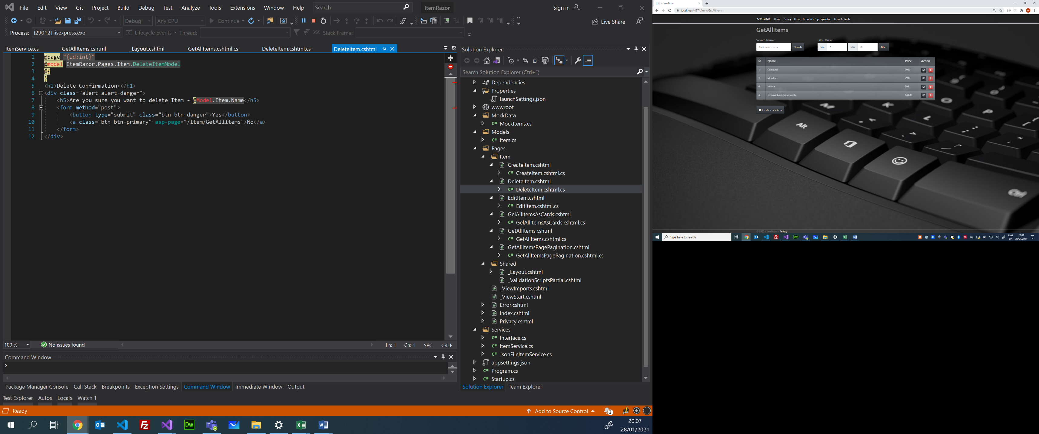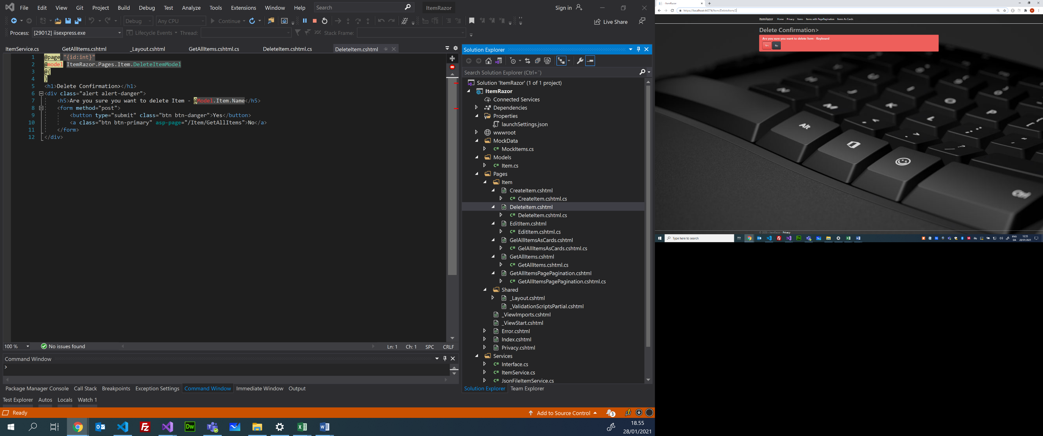

**Bemærk:** OnGet() kalder GetItems() på ItemService der returnere listen af Items og opdatere View’et – se evt tidligere Arkitektur tegning!

5

**DI**

4

RedirectToPage("GetAllItems");

GetAllItems.cshtml.cs

ViewModel

Controller

**OnGet(int id){…}**

DeleteItem.cshtml

View

PageModel

PageModel

DeleteItem.cshtml.cs

ViewModel

Controller

GetAllItems.cshtml

View

Razor Pages

Model

Item.cs

Models

DeleteItem.cshtml

DeleteItem.cshtml.cs

1

<https://localhost:44374/Item/DeleteItem> (method: post)

Bemærk: forms – submit er pr default et http-post request

public IActionResult **OnPost()**

{

     Models.Item deletedItem = itemService.**DeleteItem(Item.Id);**

     if (deletedItem == null)

           return RedirectToPage("/NotFound"); //NotFound er ikke defineret endnu

     return **RedirectToPage("GetAllItems");**

}

@page "{id:int}"

@model ItemRazor.Pages.Item.DeleteItemModel

@{

}

<h1>Delete Confirmation></h1>

<div class="alert alert-danger">

    <h5>Are you sure you want to delete Item - @Model.Item.Name</h5>

    <form method="post">

        <button type**="submit"** class="btn btn-danger">Yes</button>

        <a class="btn btn-primary" asp-page="/Item/GetAllItems">No</a>  
    </form>  
</div>

3

2

ItemServicel.cs

public class ItemService

    {

        private List<Item> items;

       public Item **DeleteItem**(int itemId)

        {

            Item itemToBeDeleted = null;

            foreach (Item i in items)

            {

                if (i.Id == itemId)

                {

                    itemToBeDeleted = i;

                    break;

                }

            }

            if (itemToBeDeleted != null)

            {

                items.Remove(itemToBeDeleted);

                JsonFileItemService.SaveJsonItems(items);

            }

            return itemToBeDeleted;

        }

**DeleteItem(id){….}**

**OnPost( ){…}**

Services

Razor Pages Arcitecture (Handler del 2 – Delete Item)

C/ Henrik Høltzer – Zealand 28.01.2021

ItemService.cs

**DI**

AddItems(…)

GetItem(id)

Service